**Software Project Management Plan**

Team Miaowa Cao

myFarmXchange

May, 2017 Revision: 1.0

**Executive Summary**

This report tracks the process that Team Miaowa Cao do the myFarmXchange project. The main content for this report is to research how to improve the efficiency of team work and how to make the project be completed better using Agile Scrum. Therefore, there are four parts presented in this report. Firstly, in the Project Management Plan section, this essay states the workflow which the Team Miaowa Cao follows to do this project and it also shows the work allocation for all team members. Moreover, this report presents the list of high-level “epic” User Story according to the real requirements from clients and provides the proposed solution for them in the Narrative Overview section. Furthermore, the solution overview part will provide several detailed proposed IT solutions for the first release of the project. Additionally, the concrete low-level tasks will be pointed out in the SDLC section. Finally, there are burndown and burnup diagrams to record the completeness situation of the project.

**Table of Contents**

// TODO: maybe create automatically

1. **Introduction**
   1. **Purpose of Document**

This document formally outlines the project management plan which is used by Team Miaowa Cao during the myFarmXchange Project. It focuses mainly on four sections: Project Management Plan and Software Development Life Cycle which both them are using Agile Scrum, Narrative Overview and Solution Overview. In these sections, it tries to present the team structure, project organization, task allocation, managerial and technical processes, and the project schedule detailedly to make all of stakeholders to engage this project tightly and clearly.

* 1. **Scope of Project**

**（focusing on time, cost and business-value criteria）**

* 1. **Audience of Document**

The intended audience of the document is all project stakeholders including the founders: Wilma Flint and Barnaby Rubble, the sponsor: Rural Infrastructure Fund, the project supervisors and all team members.

* 1. **Limitations of Document**

The limitations of the document focus mainly on two aspects: time and resources. Firstly, our group just has two months to do research for the project. It is not enough to master Agile Scrum and to know the Project Management Plan very well. Additionally, Team Miaowa Cao has been limited to access some kinds of resources, such as physical resources and personnel resources during the course of the project. We cannot set a fixed meeting room to engage Agile Scrum tightly and the requirements from the virtual clients is not explicit. For the myFarmXchange project, there is just 50,000 dollars will be sponsored by the Rural Infrastructure Fund.

**2 Project Management Plan using Agile Scrum**

**a. Identification of PMP phase**

Our group divide the project into four phases（Chandana， 2012）:

envision: “identifies customer’s vision of the project, decides the key capabilities required in the project, set the business objectives of the project, identifies the quality objectives of the project, and identifies the right participants and stakeholders of the project and plans how the team will deliver the project.”

speculate: “the product vision into a backlog of requirements is translated, the overall approach to meet the requirements is realized and a high level release plan for the product is presented.”

explore: “explores various alternatives to implement and fulfill the requirements of a project.”

adapt: “reviews the results of execution, the current situation, performance of the team against the plan and adapt as per the requirements.”

**b. A list of high-level PMP project tasks**

Each card in list represents a high-level PMP project task. The lists which we locate our card in is the phases that the tasks in. Also, the labels can be used to distinguish the phases.

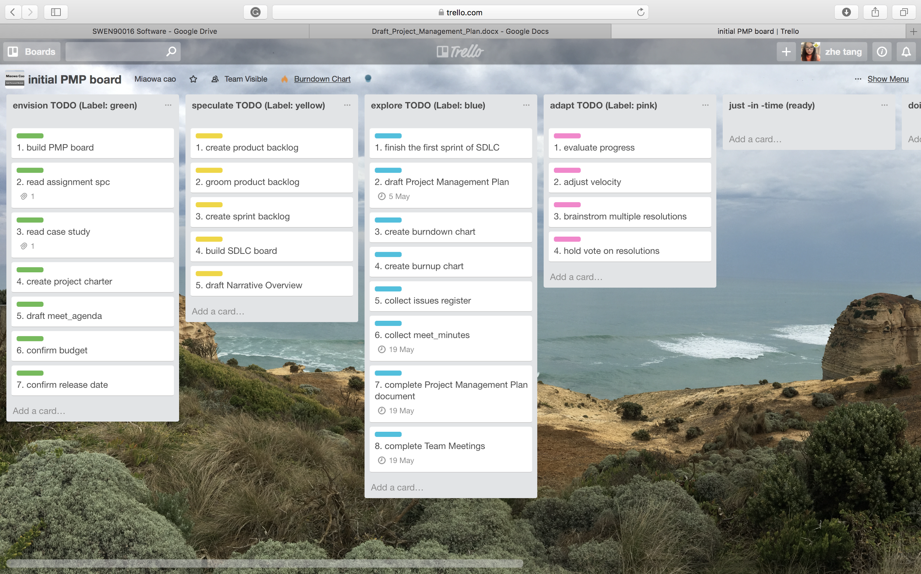

**c. A list of decomposed low-level Sprint project tasks with time estimates**

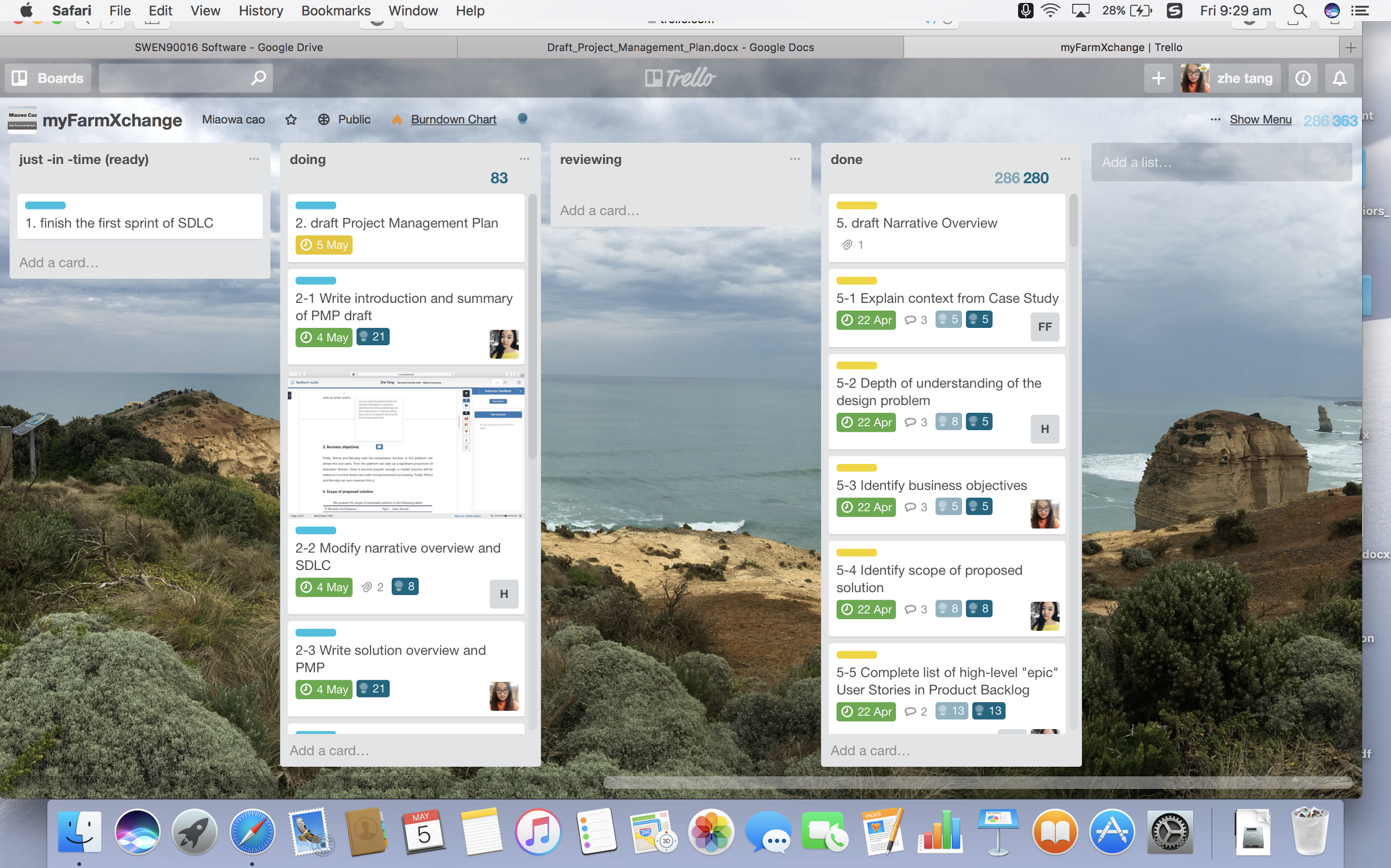

**d. estimation: How to allocate story points**

Our team decide to use Fibonacci numbers as our story points to estimate our PMP tasks. We set the minimum number to be 1 and the maximum number to be 21.

The advantage of Fibonacci numbers over successive natural numbers is that Fibonacci sequence helps us to recognise uncertainty of estimation. For example, it is easier to say 5 is more than 3 than to say 5 is more than 4.

Considering our user story is not that large, we think range from 1 to 21 is enough. Because the larger the story is, the more uncertainty there is[1].https://dannorth.net/2009/07/01/the-perils-of-estimation/

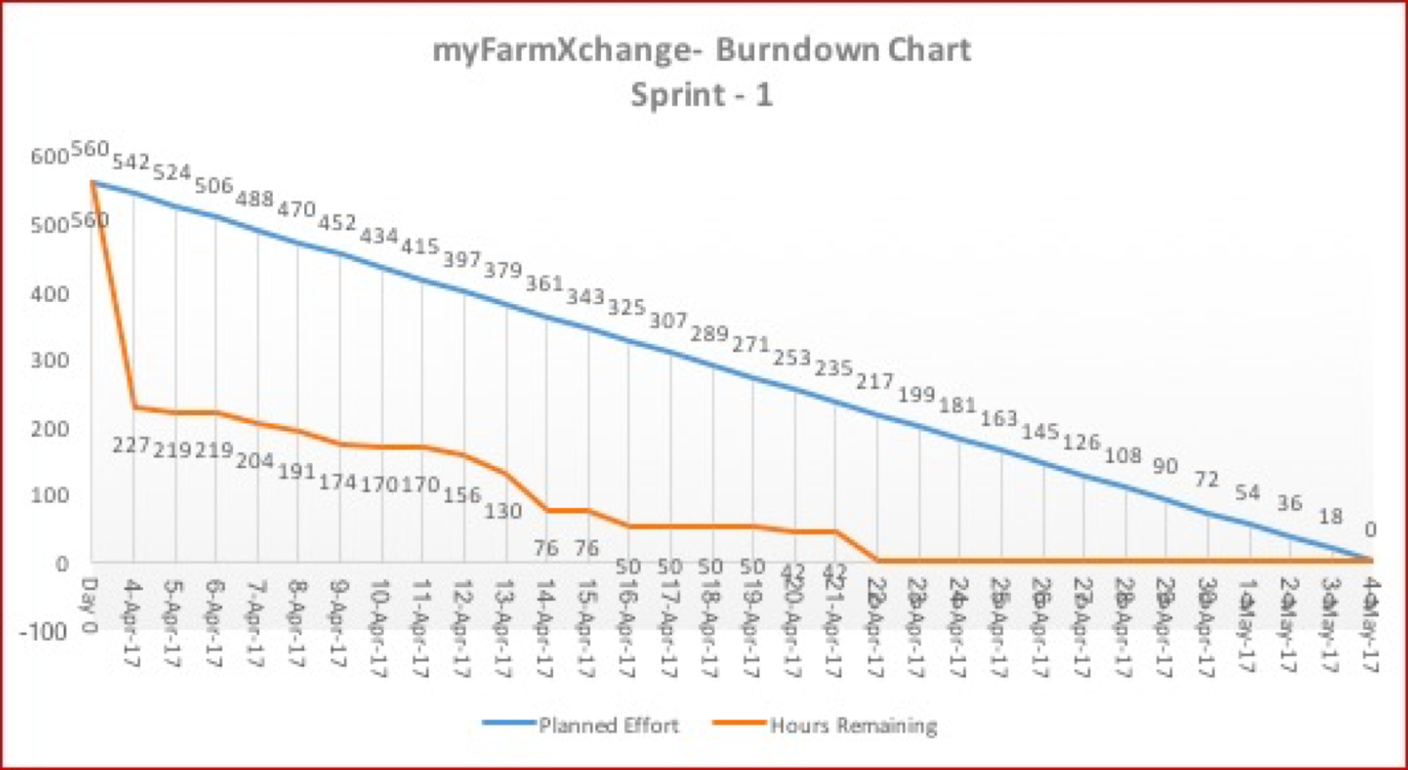

**e. screen shot/link doing-review-done**

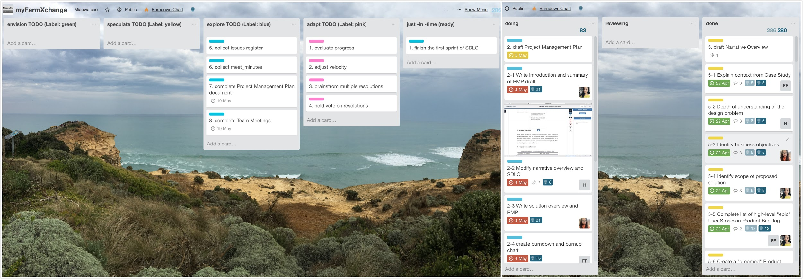link: https://trello.com/invite/b/YbVAbYFx/39e8a26c7c68bf2349682fe42e6ef4a8/myfarmxchange

**f. accurate effort**

There are some differences between the estimated story points and actual ones, which is common in agile. Till now, during tasks have been done, the total estimation points are 280 with actual points being 280. The largest error in our estimation is the “decompose epics into user story”, which is 8.

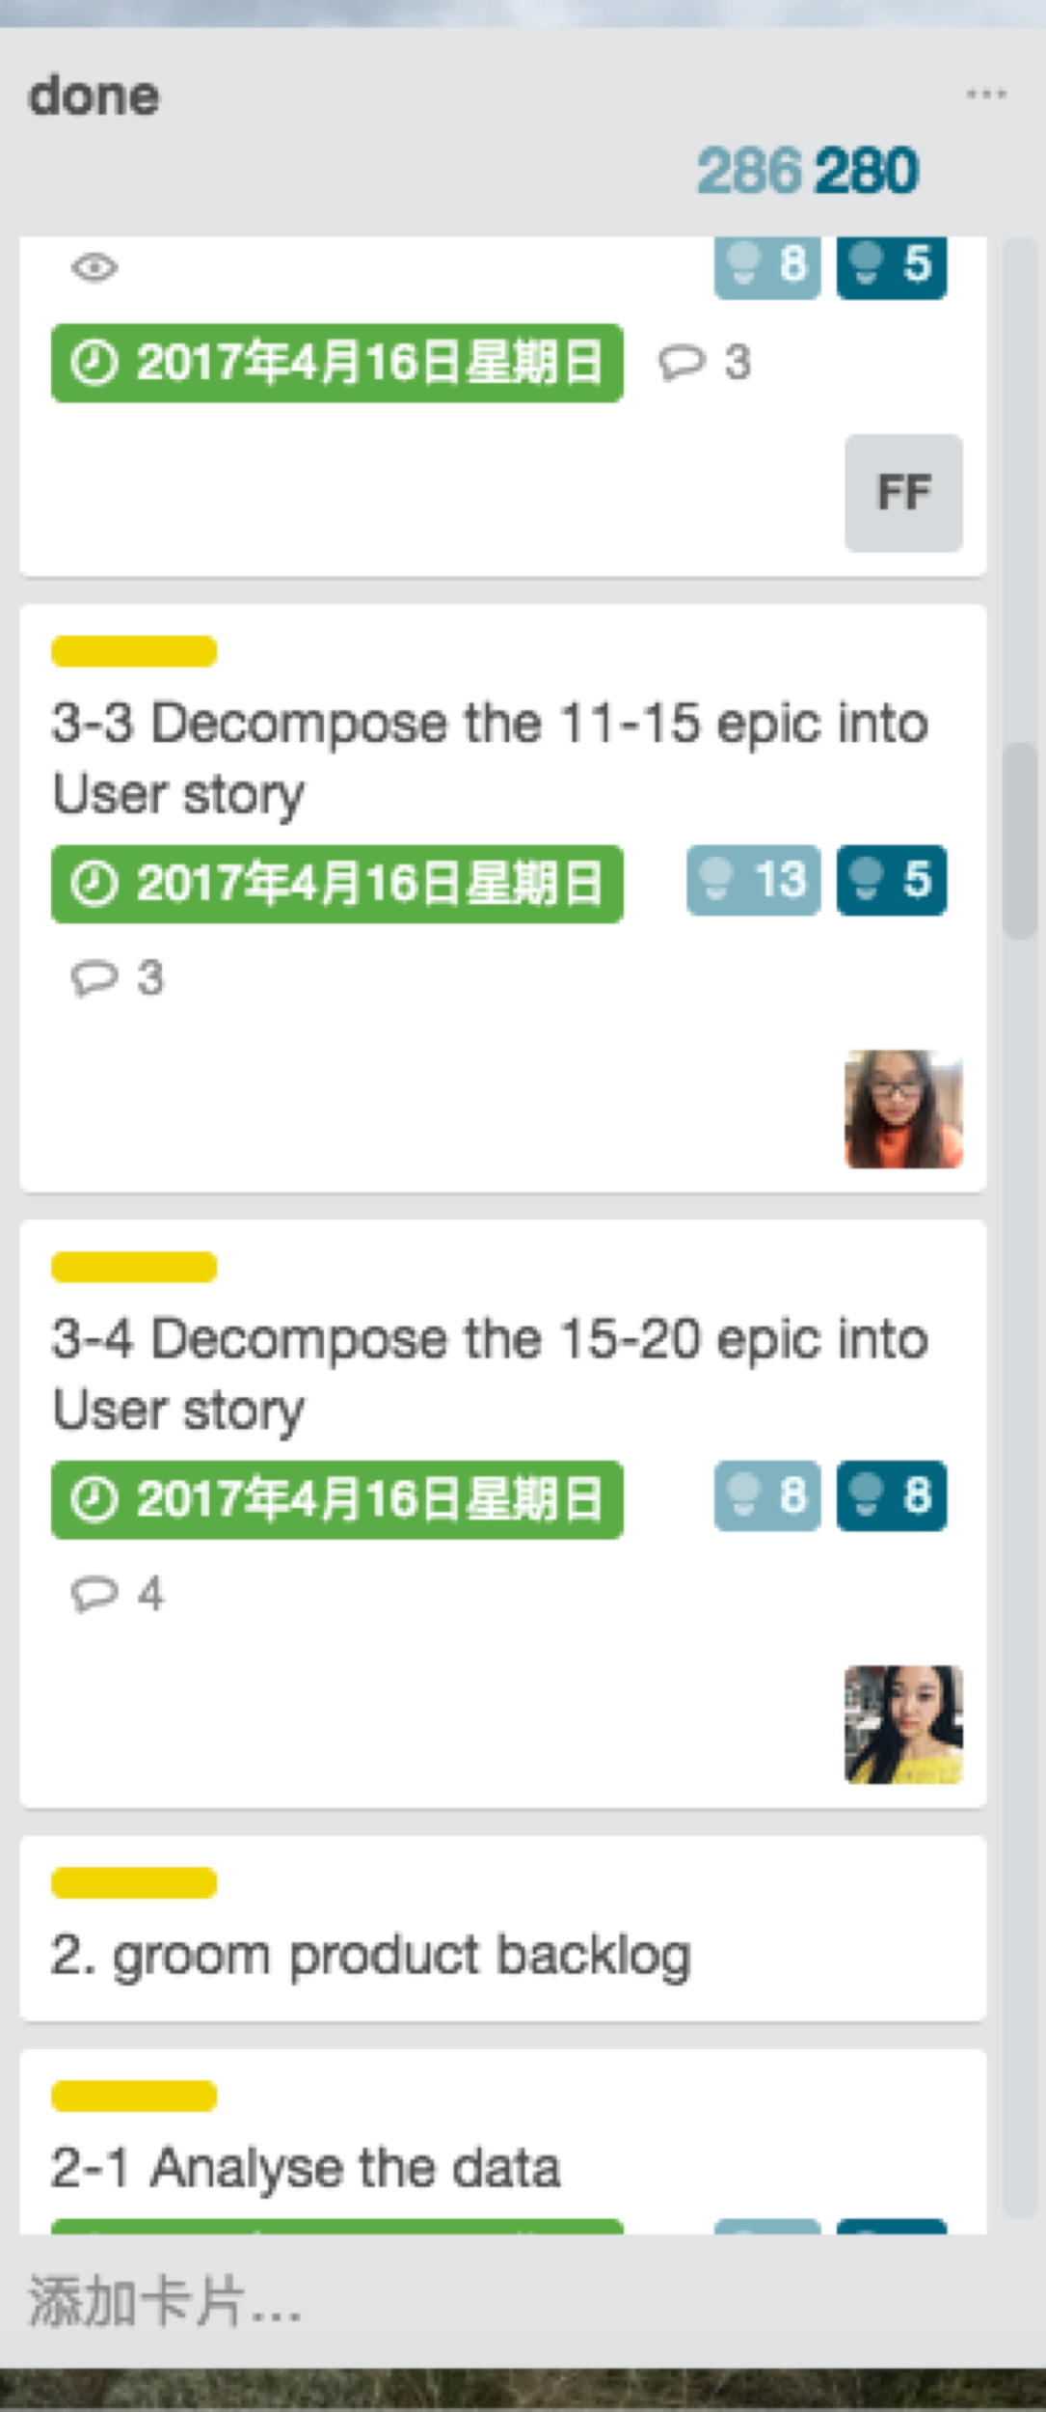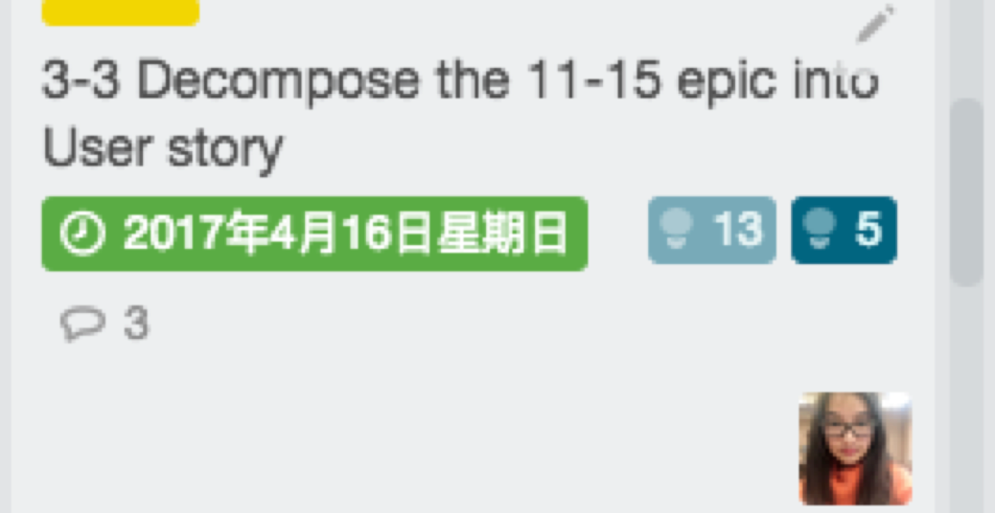

**g. how sprint is progressing by a burnup chart**

A burndown chart combines completed work and total work into one single line, whereas a burnup chart uses two separate lines. It shows more clearly how much work has been done and the total amount of work[xx].http://www.clariostechnology.com/productivity/blog/burnupvsburndownchart

Our burnup chart is shown as figure xx.

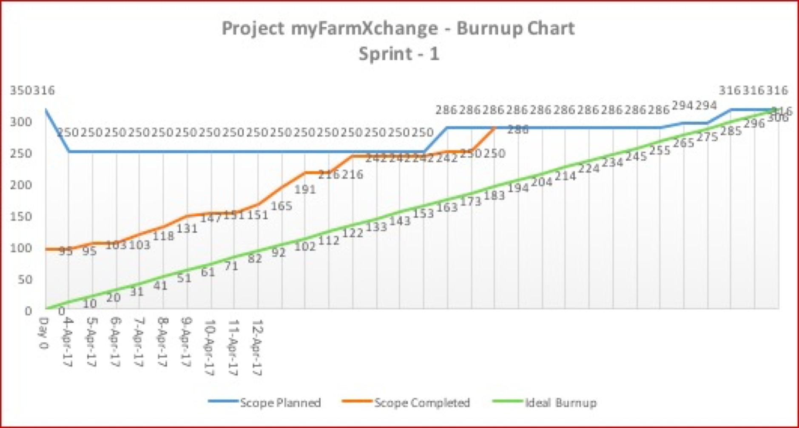

**3 Narrative Overview**

**1. Feedback**

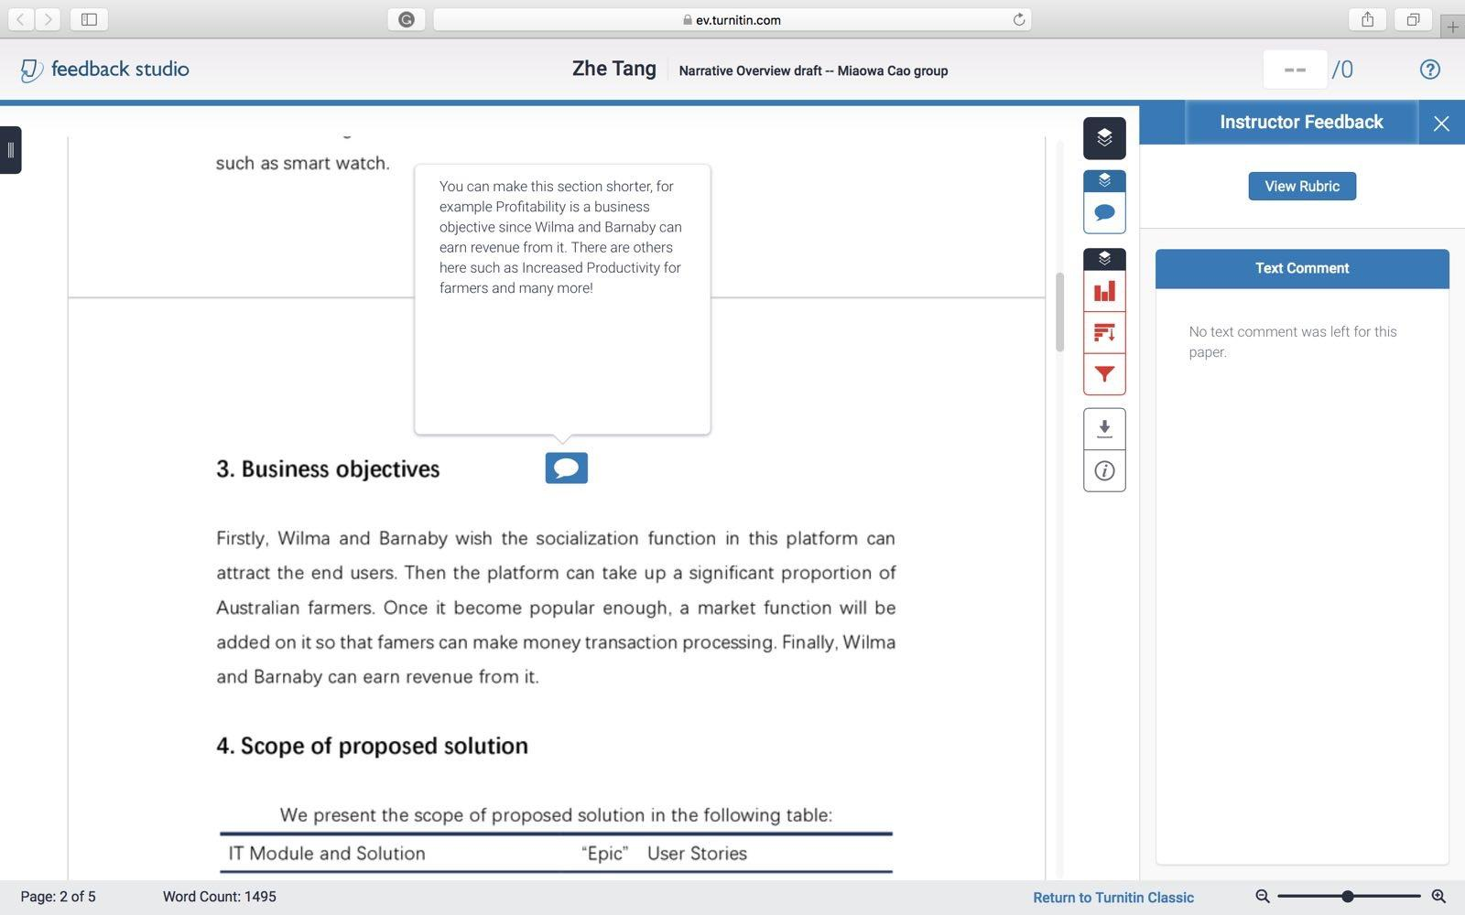

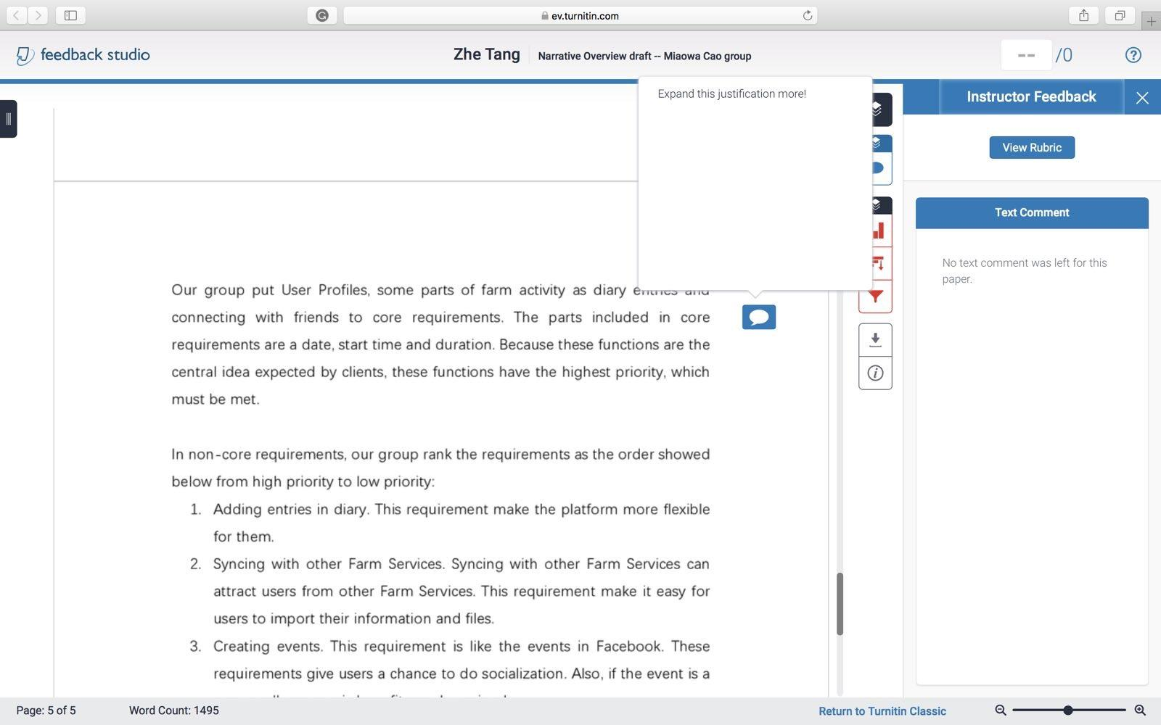

According to the feedback, we do the changes in Business objectives and “groomed” product backlog list. We modify the content in business objective and make a table to show that. Also, we add some evidences to “groomed” product backlog list for why we rank the ‘epic’.

**2. Context from case study**

Firstly, the case study introduces the background and aim of the MyFarmXchange. Wilman Flint and Barnaby Rubble plan to develop a software named MyFarmXchange. The purpose of this project is to enable farmers to form unified trading blocs to improve farmer’s economic prosperity selling grain and their community connections.

Then, the case study shows the features and requirements of the platform. The platform should include some central functions, like recording farm indicators and socialization between users. It should meet these requirements: User profiles, Diary Entries, Manual Entry, Social Interaction. Also, Wilman Flint and Barnaby Rubble wish this platform can appeal to end users and take up a significant proportion. After the platform is released, revenue may be expected. In the future, Wilma and Barnaby wish this platform can be developed to an “eBay style” transaction processing facility.

**3. Design problem**

This project should be able to run on many different platforms. On many different Operation System. Just see the mobile phone part. There are 3 main different OS on mobile phones, which are IOS, Android and windows. As for browsers, there are even more existing on the world. It may be difficult to match all the browsers or the OS.

Another problem in design may be the size. It is hard to design a properly size of this project. It cannot meet all requirements if the size is too small. And we cannot make it too large because it should be able to be used on small mobile devices such as smart watch.

**4. Business objectives**

|  |  |
| --- | --- |
| Business objectives | Reasons |
| Profitability | Wilma and Barnaby can earn revenue from it |
| Productivity | Wilma and Barnaby want to produce a social media platform, which can Increase productivity for farmer |
| Competitive Analysis | Wilma and Barnaby see their key differentiator from their competitors as the social media aspect of their vision |
| Increase Market Share | Wilma and Barnaby are hoping the social aspects of the platform appeal to end users and the platform will build up loyalty with a significant proportion of Australian farmers. |
| Core Values | Wilma and Barnaby want to enable farmers to form unified trading blocs, to improve both the farmer’s economic prosperity selling grain and the farmer’s community connections. |
| Growth | Wilma and Barnaby would like to offer an “eBay style” transaction processing facility in the future. |
| Marketing | Wilma and Barnaby want their platform to sync with mobile devices and other farm services. |

**5. Scope of proposed solution**

We present the scope of proposed solution in the following table:

|  |  |
| --- | --- |
| IT Module and Solution | “Epic” User Stories |
| Log-in Module | 4 |
| UI Module | 2, 13, 14, 17 |
| Data Type Transfer | 3, 15, 18 |
| Authentication Module | 4, 6 |
| Database Model | 1 |
| Entries Publish and Management | 5, 9, 10, 12, 19 |
| Real-time Location Module | 29 |
| Social Function Module | 6, 7, 8, 11, 12 |
| Information Synchronized | 1, 2, 13, 14, 17, 19, 20, 21, 22, 23, 24, 25, 26, 27, 28, 30, 31 |
| Multiple Account Synchronized | 25, 26, 27, 28, 30, 31 |
| Safety Module | 4, 6 |
| Payment Module | 32 |

**6. List of high levels “epic” User stories**

|  |  |
| --- | --- |
| **Action** | **Result** |
| 1.Store all data, resources and information in a database | Resources in platform can be managed |
| 2.Create a website for computer | Computers can be used |
| 3.Transfer the form of data from computer to a unified form | Data from computer can be stored |
| 4.Confirm the identity of registered | Anti-social behavior can be blocked |
| 5.Build a farm activity management system | Different farm activities can be tracked |
| 6.Build a personal profile page | Personal information can be recorded |
| 7.Build a friendship management system | Socialization can be improved |
| 8.Build a comment system | Social communication can be enhanced |
| 9.Build a concrete farm measurement system | Performance and improvements of farm can be tracked |
| 10.Build an indirect measurement system | Productivity innovations can be fostered |
| 11.Build an attachment system | Videos and photos can be shared |
| 12.Build an event management system | Social interaction can be enhanced |
| 13.Create a mobile application for ios | Platform can be available from iPhone |
| 14.Create a mobile application for android | Platform can be available from android mobile phone |
| 15. Transfer the form of data from phones to a unified form | Data from phones can be stored |
| 16. Build an text-based diary entries management system | Text-based diary entries can be shared |
| 17.Create an application for smart watch | Platform can be available from smart watch |
| 18.Transfer the form of data from smart watch to a unified form | Data from smart watch can be stored |
| 19.Build a system to publish diary entries automatically | Diary entries captured by mobile devices can be published automatically |
| 20.Create an interface for soil test kits | Measurements from mobile devices can be tracked |
| 21.Create an interface for wireless weather stations | Weather predictions from mobile devices can be tracked |
| 22. Create an interface for fitness tracking wrist bans | The number of steps a person takes a day can be tracked |
| 23. Build an accepted system for data from Mobile Device | Data from mobile device can be uploaded to the platform |
| 24. Build a syncing system for Mobile Device | Data uploaded from mobile device can be synced with the platform |
| 25. Build an accepted system for data from other platforms | Data from other platforms can be uploaded to the platform |
| 26. Build a syncing system for other platforms | Data uploaded from other platforms can be synced with the platform |
| 27.Create an interface for Australian Crop Forecaster | Weather predictions data from Australian Crop Forecaster can be accepted |
| 28.Create an interface for FitBit | Lifestyle and fitness data from FitBit can be accepted |
| 29.Build a GPS receiving system | Location can be recorded |
| 30.Create interfaces for GrainCorp | Transaction data from GrainCrop can be accepted |
| 31. Create interfaces for ProFarmer | Transaction data from ProFarmer can be accepted |
| 32.Create an interface for payment | Payment can be processed |

**7. “groomed” product backlog list**

The requirements in this platform can be divided into two parts: core requirements and non-core requirements.

Our group put the first 15 ‘epic’ into the core requirements, which are put into the first release backlog. The first release backlog includes the basic functions that Wilman Flint and Barnaby Rubble wish in their platform. Firstly, a central database is needed, because we need this to store all data, resources and information. Then we need an UI and data transfer system for computer, where the basic platform locates. For using the bais platform, register management system is important to confirm the identity of registered, which can distinguish the limitations of users. Also, the central idea of the platform is for people to be able to record farm indicators in a ‘diary’. Therefore, we build a farm activities management system to manage the farm indicators. “Over time, users will be able to see how their farm has performed and track improvements. While there are similar platforms currently available, Wilma and Barnaby see their key differentiator from their competitors as the social media aspect of their vision.” Hence, we build some social interactions system, consisting of personal profile page, friendship management system and a comment system. These actions above are put into the first sprint by our group.

After that, we add some functions into the second sprint, which are less important than the functions in the first sprint. Firstly, we almost finish the functions of diary entries, by building a concrete farm measurement, an indirect measurement system and an attachment system. Then, we would like to build an event management system to enhance the social interaction. Finally, we meet the requirements, that the platform allow users to access the platform from the various devices, apps, browsers and other online services, by creating UI and data transfer system for phones. Because these functions are the central idea expected by clients, these functions have the highest priority, which must be met.

In non-core requirements, our group rank the requirements as the order showed below from high priority to low priority:

1. Build an text-based diary entries management system

2. Create an application for smart watch.

3. Transfer the form of data from smart watch to a unified form

4. Build a system to publish diary entries automatically

5. Create an interface for soil test kits

6. Create an interface for wireless weather stations

7. Create an interface for fitness tracking wrist bans

8. Build an accepted system for data from Mobile Device

9. Build a syncing system for Mobile Device

10. Build an accepted system for data from other platforms

11. Build a syncing system for other platforms

12. Create an interface for Australian Crop Forecaster

13. Create an interface for FitBit

14. Build a GPS receiving system

15. Create interfaces for GrainCorp

16. Create interfaces for ProFarmer

17. Create an interface for payment

The reason why we put the requirements into non-core requirements is that the requirements is the improvement functions of the platform instead of the basic functions. We rank the requirements, according to the importance of ‘epic’. Firstly, we build an text-based diary entries management system to add text-based diary entries by users. Also, we create an application and data transform system for users to use smart watch. Then, the platform can be improved by letting the platform sync with mobile devices and other farm services. Also, we can build a GPS receiving system, that give users an option to receive a standard GPS file format. Lastly, an interface for payment is for future enhancements.

**8. Stakeholders.**

Stakeholders should be Wilma Flint and Barnaby Rubble, those farmers who will use this apps, server provider and OS provider.

**4 Solution Overview**

**1. IT solutions**

The software will provide a platform for farmers to communicate. We will have many problems while we handle this project. This platform should provide database to support farmers’ data record. And provide different API for different roles using this platform.

The myFarmXchange consists of many components, as shown below:

**Computer Webpage**

This part will be developed by HTML and CSS. The image interface will be organized by HTML. The simple logical part consists of CSS code. They will provide a user interface for the user. With the ability to connect with central database, it provide a API for user to store their data.

**Logical Layer**

This part will handle logical operations with JAVA code. It will block some operations from users without NGR. It will handle the translation part including function of opening sockets and the function unifying data . This part will provide a safe environment for users and also guarantee the translation process.

**Central Database**

Our database has two parts, which are hardware part and software part. In the software part, we use MySQL as software language. It is a kind of relational database, it is a stable database. it also has a good scalability. That means when the number of users increase, we can adjust the database.

**Mobile device**

We will develop this part using JavaScript because This develop language is supported by all operation system. There are many different mobile device operation systems, so we need to develop them separately. By using this kind of language, we can develop APP in each kind of device.

**2. Business Driver**

We provide the central database so it can get data and store what we want to reserve. It can give farmers information when they want. We also provide many different API so that they can connect to our platform on different devices. All this could provide them a convenient life, so more farmers would like to use our platform. The more they use, the more we will earn.

Considering the importance of sociality to human, we also provide a friend system. This function could help us keep the user. What’s more, they may recommend their friends to use this platform. it can help us save cost on advertising.

**3. Sprint Backlog**

In the first sprint, we would like to complete the epic below:

|  |  |
| --- | --- |
| **Action** | **Result** |
| 1.Store all data, resources and information in a database | Resources in platform can be managed |
| 2.Create a website for computer | Computers can be used |
| 3.Transfer the form of data from computer to a unified form | Data from computer can be stored |
| 4.Confirm the identity of registered | Anti-social behavior can be blocked |
| 5.Build a farm activity management system | Different farm activities can be tracked |
| 6.Build a personal profile page | Personal information can be recorded |
| 7.Build a friendship management system | Socialization can be improved |
| 8.Build a comment system | Social communication can be enhanced |

The user story of these epics is below:

1.1 As an administrator, I want all data stored in one place so that I can manage them easily.

1.2 As a user, I want my all records to be stored so that I can track my data.

1.3 As a user, I want to send and receive my data quickly so that I will not wait for a long time

1.4 As a user, I want all my data to be consistent so that I will not get wrong data.

2.1 As an administrator, I want the platform can be reached from computer web page so that I can manage the platform on my computer.

2.2 As a user, I want to access the platform through my computer so that I can do operations using my computer.

3.1 As an administrator, I want the form of all data to be unified so that the database can be easily maintained.

3.2 As a user, I want the form of all data to be unified so that the system can be more reliable.

4.1 As an administrator, I want users to be divided into active members and observers so that I can manage their limitations.

4.2 As an administrator, I want active users to provide a valid NGR number so that posts will not be anonymous.

4.3 As a user, I want to have an option to be an observer so that I can see others’ diary entries.

4.4 As a user, I want to have an option to be an active user providing my official NGR number so that I can create entries.

5.1 As an administrator, I want to manage all farm activities so that illegal activities can be blocked.

5.2 As a user, I want to be able to publish my farm activities so that I can see how my farm has performed.

5.3 As a user, I want farm activities to be recorded so that I can track the activities.

6.1 As an administrator, I want to record users’ profile so that I can manage the information of users.

6.2 As a user, I want to be able to publish my personal detail so that others can realize me.

6.3 As a user, I want to see other’s personal profile so that I can decide whether I will accept the friend requests.

7.1 As an administrator, I want to record friendship between users so that I can manage the connection between users.

7.2 As a user, I want to search for and connect with other users so that I can see other’s diary entries.

7.3 As a user, I want to decide whether I will approve the request so that security can be improved.

7.4 As a user, I want to have options to delete connection so that I can end a relationship.

7.5 As a user, I want to have options to report others so that anti-social behaviour can be blocked.

8.1 As an administrator, I want to record comments made between users so that offending users can be removed from the platform.

8.2 As a user, I want to comment on others’ entries so that I can have social interaction with others.

8.3 As a user, I want to see others’ comments on my diary entries so that I can review my work.

**5 Software Development Life Cycle**

**a. team velocity**

We use the same story-points-allocation policy as in PMP tasks, therefore, team velocity could be estimated from there. As is shown in figureXX, which is another version of burnup chart, we infer that we could complete 90 points in a week.

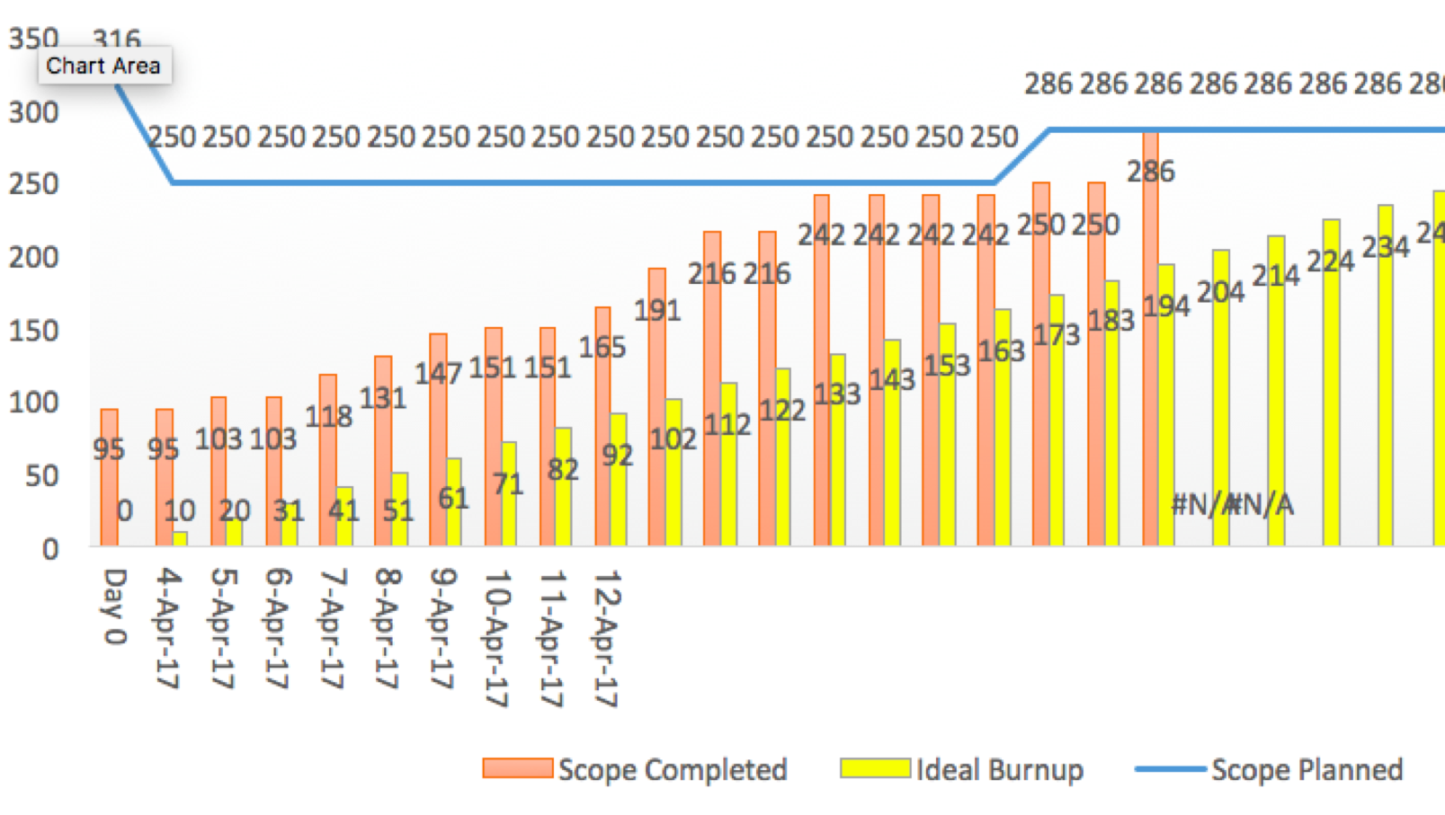

**e. sprint duration, burndown chart**

The total story points of tasks for first sprint on SDLC board are 205. Based on our team velocity, which is 90 points a week, the duration we estimate for the first sprint is approximately 3 weeks.

**f. Describe how to monitor progress using a Burndown Chart and scope creep using a Burnup Chart**

A burndown chart shows how much work is remaining to be done in the project.

A burnup chart uses two separate lines for completed work and total work. It shows more clearly how much work has been done and the total amount of work.

What’s more, a burnup chart shows scope change clearly. If a client suddenly demand extra feature, or some work is removed, the scope changes. Although in this project, there are not much demand change from clients.

Reference：

### Chandana. (2012). Agile Certification Training: Agile Project Management Framework. Retrieved from https://www.simplilearn.com/apm-framework-article.